 | Tax season is a great time to discuss long-term care planning with your family or at your workplace
This is the season where people across the country participate in a common ritual – preparing and filing their annual tax returns. Tax season presents a perfect opportunity to talk to your CPA and your insurance agent about the importance of LTC insurance and the available tax deductions.
Here are a few key concepts that you should discuss about LTC insurance:
 | ✓ |  | LTC INSURANCE PREMIUMS MAY BE TAX DEDUCTIBLE  Learn if you are eligible for a deduction or credit on your state tax returns for premiums paid for your LTC insurance | 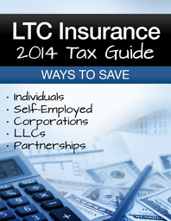
 | ✓ |  | USE YOUR TAX REFUNDS TO FUND YOUR LTC INSURANCE PREMIUMS  Never worry about paying for your LTC premiums again
 | ✓ |  | LTC INSURANCE IS THE MISSING PIECE IN MANY FINANCIAL PLANS  Tax preparation provides the opportunity for you to review your financial plans and identify any gaps in your coverage
 | Contact me for more information on the potential tax benefits of LTC insurance
Mary T. Lavelle, CPCU, CLTC
9150 South Hills Boulevard, Suite 200
Broadview Heights, OH 44147
216-642-9556 ext. 326 – 800-916-0064 maryl@sfbrokerage.com

